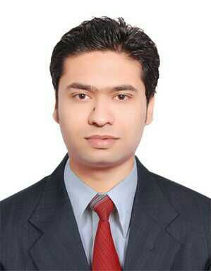
CURRICULUM VITAE

A.A.Haq Farooqui Gibran
Phone: 9640287865, 9848785586; E-mail: jibranfarooqui@yahoo.com

Career Objective:

Looking forward to be a part of a workplace where I can contribute my academic and interpersonal skills, work with enthusiasm, and have an implied personal development.

Academic Credentials:

• Completed MBA (Finance) from Nizam institute of Business Management in 2012.
• Completed BCom Computers from Aurora Degree College in 2009.
• Class XII from Nalanda junior college, Hyderabad in 2006.
• Class X from Nalanda High school, Hyderabad in 2004.

Work Experience:

- Working with HSBC India from January 2013.
- Worked with Bank of America (BA Continuum Solutions Pvt. Ltd.) for a period of over three and half years.

Appreciations:

- Appreciated for giving ideas in order to expedite the whole working process.
- Appreciated for being the SPOC (Special Point of Contact) of many activities on the floor.
- Have been lauded for portraying leadership qualities at workplace.
- Was into the top 10 inter-disciplinary projects among 300 odd projects in college.
- Was part of a social event in co-ordination with NGO-Bhoomi

Strengths:

- Good communication skills
- Passion to work
- Belief in Team Spirit
- Adaptability to new environments.
- Socially sound

Technical skills:

- MS Office, HTML and SQL
- Accounting package-Tally, VB script.
- Internet Skills.

Personal profile:

• Name : A.A.Haq Farooqui Gibran
• Date of Birth : 05-11-1988
• Father’s Name : Abdul Hameed Farooqui
• Nationality : Indian
• Religion : Islam
• Gender : Male
• Languages Known : English, Hindi, Urdu & Telugu
• Address : 20-7-243/1/A/C Qazi Pura, Hyderabad
• Phone : 9640287865, 9848785586

